**Basic Functions of PySpark**

**Read:**

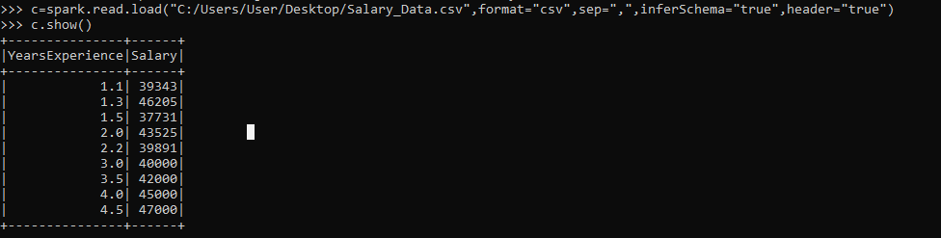

Spark.read.load() 🡺 used for load the file into spark shell

Show() 🡺 used for display the dataset.

**To Pandas:**

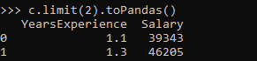

toPandas() 🡺 used for change the dataset into pandas data frame.

**Select By column:**

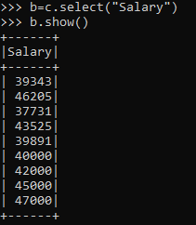

Select() 🡺 used for select specific column from dataset or dataframe.

**Sort:**

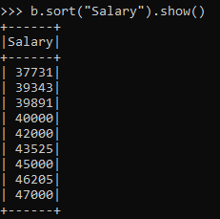

Sort() 🡺 used for sort the column.

**Filter:**

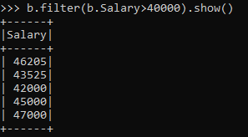

Filter() 🡺 used for filter dataset based on condition.

**Group By:**

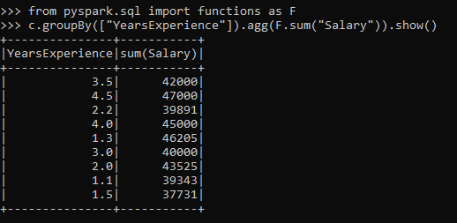

groupBy([“column name”]) 🡺 used for group by based on columns.

**SQL commands on PySpark:**

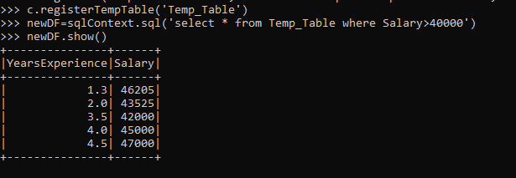

Var_name.registerTempTable(‘table_name’)🡺 change dataframe as tables for sql performance.

sqlContext.sql(‘query’)🡺 used to write sql query.

**Basic Spark Command**

**To start spark shell:**

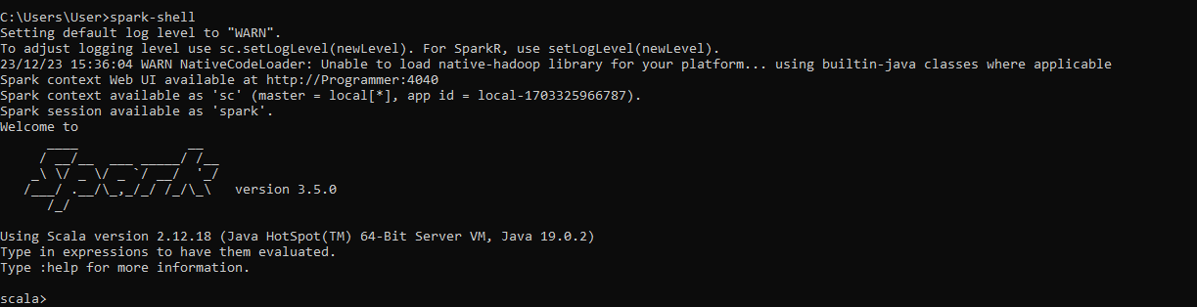

Spark-shell 🡺 used for start spark shell window.

**Read:**



Sc.textFile()🡺 read the text file.

**Create RDD through parallelizing:**

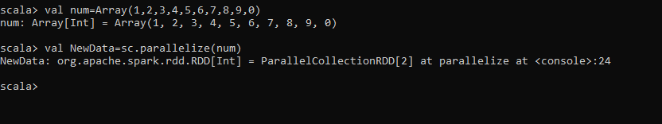

Sc.parallelize(var_name)🡺 used for create RDD dataset.

**Count items in RDD:**

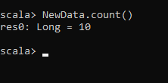

Count()🡺 gives count of records in RDD.

**Read data from RDD:**

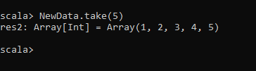

Var_name.take(range)🡺used for take data and display them.

**Quit:**

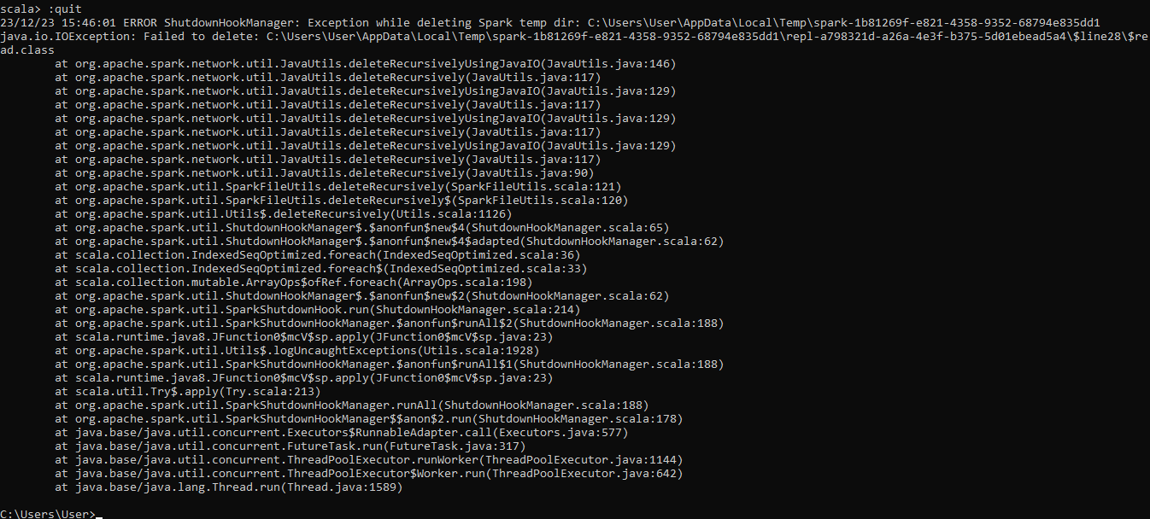

:q or :Quit 🡺 used for exit from spark shell.